**[A woman killed on charge of witch, another fed excreta](http://dignitypost.com/a-woman-killed-on-charge-of-witch-another-fed-excreta/)**

Posted By: [dignity@123](http://dignitypost.com/author/dignity123/)on: October 25, 2021In: [Global News](http://dignitypost.com/category/global/), [Human Rights](http://dignitypost.com/category/human-rights/), [Latest News](http://dignitypost.com/category/latest-news/), [Minority](http://dignitypost.com/category/minority/), [National News](http://dignitypost.com/category/national/), [Women](http://dignitypost.com/category/women/" \o "View all posts in Women)[No Comments](http://dignitypost.com/a-woman-killed-on-charge-of-witch-another-fed-excreta/#respond)

[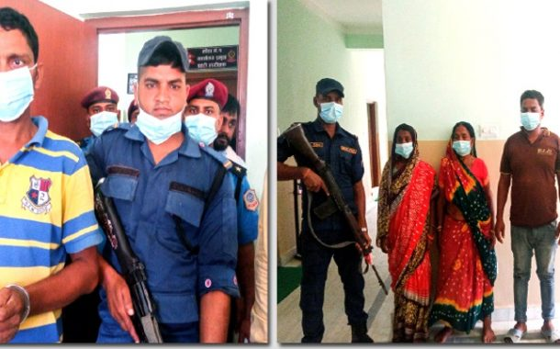](http://dignitypost.com/a-woman-killed-on-charge-of-witch-another-fed-excreta/)

**KATHMANDU:**On the auspicious eighth and ninth day of the Dashain festival a woman was brutally killed by her family members and neighbours on the charge of witch while another was fed human excreta.

Shila Devi Jha, 42, of Madai of Mahottari Municipality-3 was killed by her family members while Sukmariya Devi, 42, of Suga of Jaleswar Municipality-4 was fed human excreta and manhandled by her neighbours.

The eighth day of the ten-day-long greatest festival of the Hindus is considered auspicious for sacrificing animals to Goddess Durga but on the same day her brother-in-law Sanjay Kumar took the life of Shiladevi hitting repeatedly with a hammer on her head.

Sanjay had told the police that his sister-in-law was a witch and she forced his wife to abort by feeding a banana.

Police investigating the case have said he had planned to murder Shila Devi after a witchdoctor coming to Janakpur from India one and half month ago.

According to media reports Sanjay DSP of Mahottari district Dinesh Acharya had told the Police that he murdered sister-in-law suspecting she was a witch.

“After the witchdoctor of India told him that Shila Devi killed her husband and son and is trying to muder his wife Rinku and the child inside her womb by feeding banana Sanjay had made he plan to kill her,” DSP Acharya told the reporters.